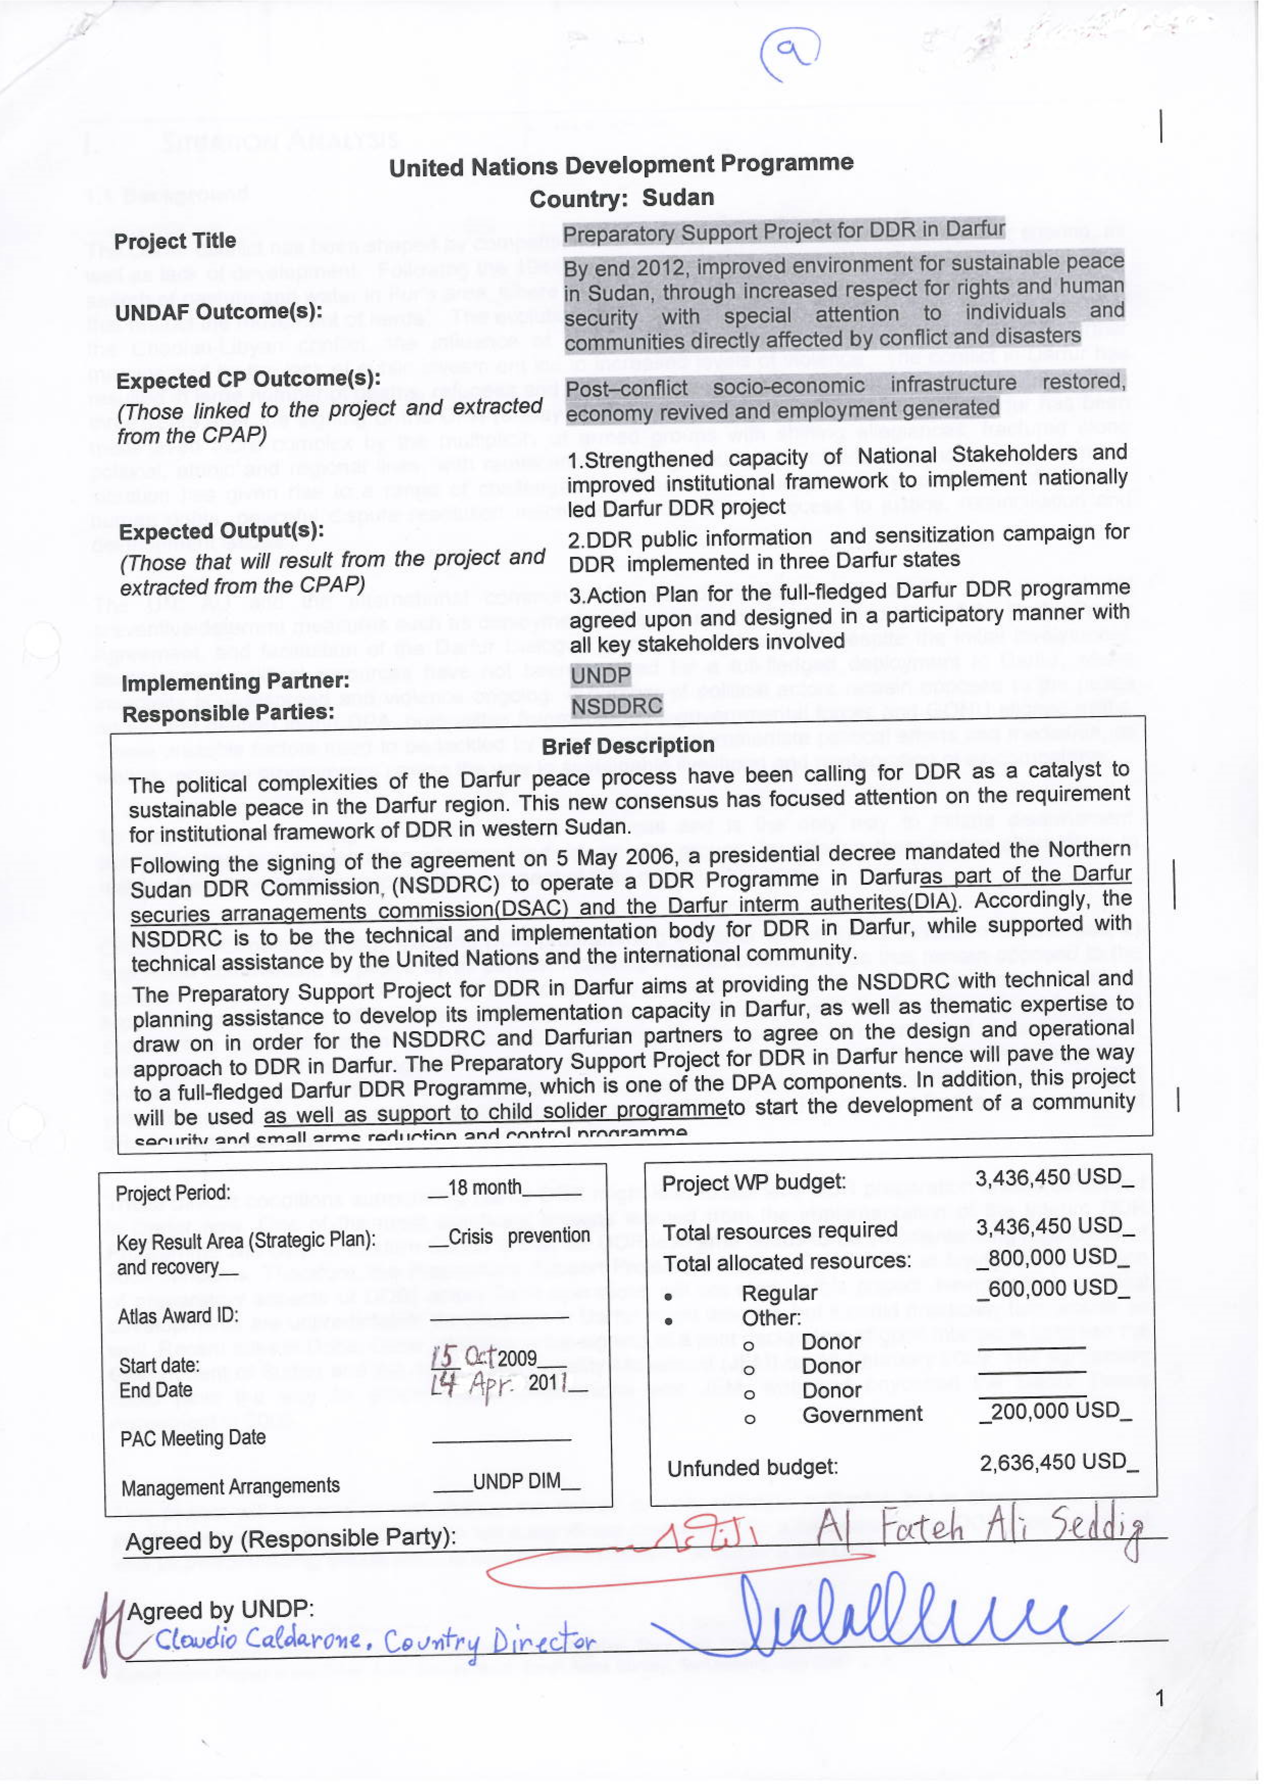

I. SITUATION ANALYSIS

1.1 Background

The Darfur conflict has been shaped by competition over access to natural resources and power sharing, as well as lack of development. Following the 1984-85 drought, large numbers of pastoralists moved south in search of pasture and water in Fur’s area, where sedentary groups were developing static farming practices that restrict the movement of herds. The evolution of the political scene in Khartoum, the regional impact of the Chadian-Libyan conflict, the influence of SPLA, and the use of proxy forces in Darfur further marginalized by the lack of public investment led to increased levels of violence. The conflict in Darfur has resulted in large number of deaths, refugees and IDPs, widespread insecurity and acute poverty. More than three years after the signing of the DPA (5 May 2006), the political and military scene in Darfur has been made even more complex by the multiplicity of armed groups with shifting allegiances, fractured along political, ethnic and regional lines, with ramifications in neighbouring countries. This increasingly complex situation has given rise to a range of challenges in terms of community security, protection of civilians, human rights, peaceful dispute resolution mechanisms, rule of law, access to justice, reconciliation and development issues.

The UN, AU and the international community intervened in the Darfur conflict and carried out preventive/deterrent measures such as deployment of Peacekeeping Forces, mediation of the Darfur Peace Agreement, and facilitation of the Darfur Dialogue among conflict parties. Despite the initial involvement, financial and political resources have not been secured for a full-fledged deployment in Darfur, where insecurity is widespread and violence ongoing. A number of political actors remain opposed to the peace agreement defined in the DPA, both within fragmented anti-governmental forces and GONU aligned militia. These unstable factors need to be tackled by a combination of immediate political efforts and mediation, as well as recovery programmes paving the way to sustainable livelihood and reintegration of ex-combatants.

To that end, re-activating the peace process is crucial and is the only way to initiate disarmament, demobilisation and reintegration of armed individuals and groups, by offering them peace alternatives to make a living and contribute to the development of their community.

Critical conditions to envisage initiating DDR programming in Darfur will be 1) the cessation of hostilities, 2) a genuine commitment to peace by all parties, including multiple armed groups that remain opposed to the provisions made in the DPA, and 3) the compliance of parties to disarmament and forces withdrawal provisions made in the DPA. The main challenge to any DDR initiative in Darfur will be to undertake a constructive joint negotiation on terms and conditions for the parties to disarm and demobilise their combatants, as well as the agreement on eligibility criteria for the individuals to enter the programme. Should the first two conditions be met and parties engage in the negotiation described above, then a DDR programme can have a meaningful stabilizing impact in Darfur and pave the ground for future recovery and development activities.

These difficult conditions surrounding Darfur DDR might lead to ask why DDR preparation should be started in Darfur now. One of the most significant lessons learned from the implementation of the Interim DDR Programme and DDR in Eastern Sudan is that the DDR lead time needs to be sufficiently long regardless of such concerns. Therefore, the Preparatory Support Project for DDR in Darfur aims at laying the foundation of preparatory aspects of DDR; actual DDR operations will not start in this project. Nevertheless, political developments are unpredictable: the situation in Darfur might drag on, but it could drastically turn around as well. Recent talks in Doha, Qatar, resulted in the signing of a joint declaration of good intentions between the Government of Sudan and the Justice and Equality Movement (JEM) on 16 February 2009. The agreement could pave the way for proper peace negotiations with JEM, who had boycotted the Darfur Peace Agreement in 2006.

This project will not and cannot change the overall security situation in Darfur, but is designed to give a positive sense towards peace and to set a significant momentum for a full-scale Darfur DDR programme, as well as peacekeeping efforts and the political environment surrounding the DPA.

1.2 DPA Commitments on DDR

The Darfur Peace Agreement clearly indicates that Disarmament, Demobilisation and Reintegration will start after the completion of a comprehensive ceasefire and a set of security arrangements, including the disarmament of Janjaweed/armed militias (art. 417). Specific principles for Disarmament and Demobilisation are outlined in article 426 of the DPA, as DDR awareness raising with commanders and forces, establishment of eligibility criteria, weapons collection and destruction, pre-registration, and immediate demobilisation and reinsertion of disabled combatants. General principles on social and economic reintegration are outlined in sections 431 to 445, in line with the Integrated DDR Standards. The DPA also plans for Security Sector Reform (art. 446 onwards), restructuring of Selected Security Institutions (SSI) and inclusion of former combatants into the said SSI (art. 399 to 416), including the Sudan Armed Forces (SAF), the Sudan National Police, the Border Guards and the Popular Defence Forces (PDF).

1.3 Small Arms and Light Weapons in Darfur

All armed actors in the Darfur conflict – SAF, PDF, GoS aligned militia and opposition armed groups – are using and have access to small arms and light weapons (SALW). SALW cause insecurity and human suffering and hamper sustainable development. Removing these weapons and addressing the causes of proliferation are a crucial part of promoting peace and creating safer societies. The DPA makes a specific provision for the cantonment of “crew-assisted weapons” (art. 370) and related ammunition.

The people of Darfur have been seriously affected by the use of SALW during past and ongoing conflicts. While few studies have been carried out in Darfur, in similar conflict contexts the majority of SALW victims and carriers are unemployed, uneducated young men. The use of SALW is widespread in various forms of human rights violations, including rape, torture, abduction, coerced recruitment, kidnapping, theft, looting, forced displacement, forced marriage and extortion. Such levels of violence have negatively impacted development indicators such as access to infrastructure, employment, healthcare, education, social welfare.

Given the combination of extreme poverty, overwhelming social wounds, emerging, untested government structures and fragile security situation it is not difficult to understand how and why violence using SALW is likely to continue. For DDR to succeed in Darfur, integrated community security programmes are required, combining conflict prevention, mitigation and management, community policing and small arms control, as well as broader economic recovery and employment support programmes targeting disenfranchised youth.

Security at the national/state level is critical in post conflict contexts and therefore engagement with governmental institutions is essential; however, local and community level security considerations should not be neglected. Community security is of equal importance both in itself and if larger peace building and security programmes are to have any impact and sustainability.

1.4 DDR National Institutions

The National DDR Coordination Council (NDDRCC) will assume the primary responsibility of policy formulation, oversight, coordination, and evaluation of the progress made by the North Sudan DDR Commission in developing its readiness to design, implement, and manage the DDR process in the Darfur states. NSDDRC will take responsibility for planning and implementing the DDR project in accordance with the policies developed by NDDRCC. One of the major roles of NSDDRC is to set up state offices and supervise the field activities conducted by them. NDDRCC has nominated the North Sudan DDR Commissioner as its representative for DDR in Darfur in the Security Arrangement Group.

1.5 The Role of the United Nations

As part of its role in supporting the implementation of the DPA, the United Nations has been mandated by UN Security Council Resolution 1769 (31 July 2007) stating that UNAMID “…having completed all remaining tasks necessary to permit it to implement all elements of its mandate, will assume authority from AMIS...” including to assist with development and implementation of a comprehensive and sustainable programme for disarmament, demobilisation and reintegration of former combatants and women and children associated with armed forces and groups, as called for in the Darfur Peace Agreement.

Until now, UNAMID and UNDP have served as the primary vehicle for UN agencies in providing support to national and international efforts and in defining the concept of operations for a unified UN approach on Darfur DDR.

UNAMID Role
- UNAMID, on behalf of the UN, will be responsible for policy coordination. Joint Special Representative to provide overall political guidance to the Darfur DDR process.
- UNAMID, jointly with NSDDRC, will be responsible for setting eligibility criteria for participating in the DDR programme.
- Demobilisation aspects of the main phase Darfur DDR programme: UNAMID to take the lead in supporting NSDDRC on demobilisation aspects.

UNDP Role
- UNDP will focus on capacity development and advocacy and partnership building as outlined by the outputs under the Preparatory Support Project for DDR in Darfur.
- Reintegration aspect of the main phase of Darfur DDR programme: UNDP to take the lead in supporting NSDDRC on reintegration aspects, such as design of economic reintegration and psycho-social activities, including for Special Needs Groups (disabled, elderly combatants, WAAFG).

Joint Responsibility
- In close cooperation with NSDDRC, develop of a project document for the main phase Darfur DDR programme, strategy and work plan.
- Establish coordination mechanisms such as a UN DDR Steering Committee for Darfur to be chaired by Joint Special Representative, following the model of the UN DDR Steering Committee for the CPA area.
- UNDP DDR Project Coordinator and staff to be co-located in UNAMID.
- Prepare MoU between UNAMID and UNDP (and other UN agencies if any) in view of joint programming for implementation of the full-fledged DDR programme.

II. STRATEGY

2.1 Guiding Principles

This project for DDR in Darfur will adhere to the principles elaborated in the Interim DDR Programme for the CPA area, briefly outlined below:

- Broadly based national ownership should be ensured;
- Developing national capacity should be prioritised;
- The project should balance equity and human security;
- The project should be responsive to disparate and changing conditions;
- The project should be conflict sensitive;
- Expectations should be managed;
- The project should spread a message that DDR will transform the region’s military-prone culture to demilitarization by embracing livelihoods that are not gained by the gun;
- The project should nurture an enabling policy and security environment;
- The project should be thought of as foundational activities in line with the efforts to scale-up Early Recovery programming in Darfur.
- The project should emphasise transparency and accountability;
- The project should be gender responsive and provide support to Special Needs Groups;
- The project should consider natural resources management, especially as it relates to the impact of natural resources on local level conflicts
- The project should take Do No Harm principles into consideration.

2.2 Objectives and Activities

The current project for DDR in Darfur is requested by NSDDR and prepared jointly by NSDDRC and UNDP to provide capacity development and technical assistance to the NSDDR Commission in gearing up towards DDR programming in Darfur. The main goal of this Preparatory Support Project for DDR in Darfur is to support all relevant stakeholders, including receiving communities, to effectively participate in the design of the Darfur DDR process through adequate and timely preparation for programme design and implementation of the multi-year comprehensive Darfur DDR programme to follow as a subsequent phase.

The immediate objective of this project is to provide timely and effective technical and operational support to NSDDRC for the design, preparation, start-up and early implementation of the Darfur DDR programme. The focus of this short term intervention will be:

- Develop the NSDDRC’s capacity to set up operational structures, including Darfurian staff, to strengthen the DDR institutional framework
- Raise awareness of key actors at regional, state and community level, together with representatives of the factions involved in the conflict, on the DDR processes, methodology and mechanisms, and understand if and how they are looking forward to a DDR process;
- Collect feedback and suggestions from representatives of sub-state level, together with communities of anticipate return for a successful DDR process;
- Design and agree on a comprehensive flow chart and process to implement the main phase DDR programme in Darfur, and define key requirements and activities for pre-registration and screening process of ex-combatants.
- Develop key programme tools including establishment of a DDR Programme Support Unit,
- Prepare a community security and small arms reduction and control strategy and programme to undertake CSAC pilot activities to address immediate necessities on the ground.

Essentially, the current project serves as a preparatory phase for the main Darfur DDR programme whilst waiting for resources to be made available for full implementation of the main phase Darfur DDR programme and for the final financial and management arrangements to be agreed and formalised between the National Commission and the UN, as well as for progress in the peace process. This preparatory project is designed to be the catalyst that allows UNDP to place expertise in Darfur at this strategic junction not only for the peace process but also to prepare UNDP to assume its lead role in reintegration in the future. To this end, the relationship between this project and broader Early Recovery efforts / programming in Darfur, including the Darfur Regional Programming Framework / DAFAP should be developed and enhanced to scale-up Early Recovery programming in Darfur.

2.3 Project outputs

The current project is aimed to produce the following outputs:

- Strengthen National Capacity and Institutional Framework for Darfur DDR
- Raise awareness and sensitise key player of DDR process on key aspects of the programme
- Agree on and design the Strategy and Action Plan for the main phase Darfur DDR programme

2.3.1 Develop National Capacity and Strengthen the DDR Institutional Framework

Capacities of national institutions will be crucial to succeed with the Darfur DDR planning and implementation.

Indispensable elements of capacity that NSDDRC and relevant key national institutions need to develop are five-fold:
- Administrative and operational capacity;
The main objectives of developing this capacity is for NSDDRC to formulate, plan, manage and implement the full-fledged DDR project, including the capacity to prepare a budget and to estimate capacity development costs for the main phase DDR. Also NSDDRC will be required to develop their capacity to manage human and financial resources and procurement in a large scale. Along with that, NSDDRC will need to have monitoring and evaluation capacity such as setting indicators for monitoring, monitoring progress, measuring results, collecting feedback to adjust policies, codifying lessons, promoting learning and ensuring accountability to all relevant stakeholders.
To this end, the implementation of the DDR programme and the realisation of its objectives require the establishment of operational bases. The capitals of the three Darfur States – El Fasher, El Geneina and Nyala – are suitable locations to establish sub-regional offices of NSDDRC. The office locations and buildings are already identified by the government/NSDDRC but not fully operational. The offices will be furnished with essential furniture and equipments. NSDDRC, with procurement and technical engineering support from UNDP, will identify the requirement and specifications of furniture and equipment.
- Capacity to engage with their government and other key counterparts in the process to develop a DDR strategy with assistance from UNDP and UNAMID;
Involvement of key counterparts such as state governors, state administrations, line state ministries (Ministry of Agriculture, Culture and Youth, Education, Labour, Water Resources, HAC etc.), and law enforcement agencies (Ministry of Defence, Police, and National Security) will be of key importance for successful implementation and sustainable outcome of DDR including CSAC. This process will not limit the above-mentioned counterparts, but rather identify more stakeholders if any. The process will aim to motivate and mobilize the counterparts and to create partnerships and networks with them towards DDR.
- Capacity to carry out and/or manage an initial baseline survey on IPs, mapping of Reintegration opportunities, national monthly income of unskilled, semi-skilled labour, macro economic research, and environmental research in order to assess a situation and define a vision and mandate for implementation of Reintegration process;
The NSDDRC and the UNDP will undertake economic baseline survey and mapping of reintegration service providers and opportunities in the three states of Darfur. The outcome of Threat and Risk Mapping and Analysis (TRMA) project in Darfur run by UNDP will be referred to for this purpose. Also This DDR preparatory project will promote close collaboration with the current UNDP’s Livelihoods Programme in Darfur (Official Title: Enhancing Livelihood Opportunities and Building Social Capital for New Livelihoods Strategies in Darfur) and will exchange the analysis and information both projects/programmes glean. Such mapping and analysis will aim at compiling in a single document the information available on livelihoods, economic recovery, training and reintegration bodies in Darfur, as well as gathering data on the prospective costs per individuals. This information will be gathered and shared with relevant stakeholders in order to allow all planners to analyze and synthesize data and information and articulate capacity assets and needs so that the planners will come up with informed budget requirements as far as reintegration is concerned.
- Capacity to conduct a public information and sensitisation campaign on DDR and CSAC that is detailed in the second sub-project on DDR public information and sensitization campaign;
Main objective is to promote engagement of civil society and the private sector which will become direct beneficiaries or potential stakeholders of the DDR process. The NSDDRC will be required to manage large group processes and open dialogue with civil populace to mediate divergent interests and to establish collaborative mechanisms so that the implementation of the DDR will run more smoothly.
- Technical capacity to conduct DDR:
Capacities of relevant personnel will be strengthened on key aspects of Darfur DDR such as developing operational guidelines and SOPs for DDR, community security and arms reduction and control activities. Training of NSDDRC staff will be conducted according to training requirements, including information and counselling methodology, with the technical assistance of UNDP throughout the current project.

To meet these requirements and to assist NSDDRC’s activities and enhance their implementing capacity in the field, UNDP will recruit staff members who are well-qualified and, in the case of national staff, from the local area. Part of the recruited UNDP staff will be embedded in each of the three DDR sub-regional offices for Darfur States’ DDRCs.

2.3.2 Raise awareness and sensitise key player of DDR process on key aspects of the programme

The DDR programmes in Sudan are fairly unknown by the vast majority of the Sudanese population. Moreover, it seems that the contents of DPA, particularly their security components, to a large extent are ignored by the people of Darfur. Lack of information is certainly fuelling the frustration over community security and arms control questions.

Major target groups for the PI and Sensitisation Campaign are defined as (1) state administrations and ministries, (2) traditional institutions (sultan) (3) religious and community leaders including women and youth and (4) armed groups who are directly involved in the Darfur conflict. An effective public information and sensitisation campaign for DDR and CSAC can help the regional government and community leaders prepare the implementation of a comprehensive DDR programme and realise that a weapon-free society is more conducive to stability and development than one in which access to weapons is prevalent. To this end, the concept and significance of small arms reduction and control as well as community security will be incorporated in the sensitisation messages.

The NSDDRC will lead the efforts on DDR sensitisation, supported by UNDP. Involvement of NGOs which have expertise and experience in outreach campaign in Darfur is worth consideration. To this end, the output of TRMA can be a useful tool to figure out the geographical and thematic fields where such NGOs have strength and presence.

(1) State administrations and ministries; and (2) traditional institutions (sultan):
The campaign for those target groups will aim to receive political support from regional political stakeholders. Conference and workshops are the main schemes.
- Religious and community leaders including women and youth:
Given Sudan's size and high rates of illiteracy, radio could be the best media to reach the large population. Theatre caravan and other cultural events to reach out the target community also will be considered depending on security conditions. In addition and to avoid security concerns in some localities, workshops will be conducted in the three capitals of the Darfur states to invite community leaders with state authorities for joint discussions.
- Armed groups who are directly involved in the Darfur conflict:
The campaign for armed groups will be expected to provide a clear picture of DDR to armed groups as direct beneficiaries and encourage them to enter the DDR process. The sensitisation activities also include joint meetings with commanders and community leaders in high priority communities in Western, Northern and Southern Darfur states.

2.3.3 Agree on and design the Strategy and Action Plan for the Main Phase Darfur DDR Programme

During the implementation of this project, joint programme formulation will be undertaken by NSDDRC, UNAMID DDR planning section and UNDP. The team will elaborate the concept, strategy and action plan of the main phase Darfur DDR – the multi-year, full-fledged Darfur DDR programme. A comprehensive DDR programme document with a well-elaborated strategy will be drafted on the basis of the experience and evolving requirements to be identified throughout the current project and other DDR projects implemented in Sudan such as the Sudan DDR Programme in the CPA area and the Eastern Sudan DDR project. The project document for the main phase Darfur DDR will be prepared by the end of this project and submitted for endorsement by the Government and the UN in accordance with formal procedures.

The main phase Darfur DDR programme will focus on carrying out the full-fledged DDR and CSAC projects in Darfur through (but not limited to) the following:

- supporting further capacity development of national and local DDR institutions and implementing partners;
- supporting the logistical and operational aspects of the DDR and CSAC processes such as weapons collection and storage;
- continuing PI and sensitisation campaigns for both state and non-state actors on the DDR processes;
- continuing the required research, surveys, assessments and data collection exercises for both DDR and CSAC (Community Security and Arms Control) programming;
- conducting profiling of DDR candidates;
- conducting assessment of reintegration opportunities and mapping of support services;
- establishing information, counselling and referral service;
- bridging the gap between demobilisation and reintegration by conducting transitional safety net project;
- seeking economic and social reintegration for ex-combatants and SNGs;
- providing support for psychosocial reintegration;

III. RESULTS AND RESOURCES FRAMEWORK
Intended Outcome as stated in the Country Programme Results and Resource Framework:
7. Post-conflict socio-economic infrastructure restored, economy revived and employment generated.
Outcome indicators as stated in the Country Programme Results and Resources Framework, including baseline and targets:
Indicator: Change in human security (mines, small arms, socio-economic) of crisis affected groups.
Baseline: Interim DDR Programme active in the North, South and East. MYDDR programme pilot launched in Blue Nile State.
Target: National Institutions technically supported for development of joint DDR policies and strategies and enabled to manage the DDR process.

Applicable Key Result Area (from 2008-11 Strategic Plan): Crisis prevention and Recovery
Partnership Strategy: NSDDRC, UNAMID
Project title and ID (ATLAS Award ID): The |  | Preparatory Support Project for DDR in Darfur
INTENDED OUTPUTS | INDICATIVE ACTIVITIES |  |  | RESPONSIBLE PARTIES | INPUTS
Output 1. Strengthened capacity of National Stakeholders and improved institutional framework to implement nationally led Darfur DDR project  Baseline:  - No proper State DDR Offices and institutions established in Darfur regions.  - Darfur-specific policies, strategy and operational capacity need to be tailored and strengthened.  Indicators:  (1.1.) Management system of Darfur DDR established and State Offices set up.  (1.2.) Darfur DDR state offices have required vacancies filled, trained and deployed.  (1.3.) Transportation, logistical and administrative capacities established to support State Offices. | Activity Result (1) Offices deployed within projected timeline, operational and implementing activities  Action1.1.: Three State Offices identified and established in El Fasher, El Geneina and Nyala  Action1.2.: Three state offices are equipped with required vehicles, furniture and office equipment  Action1.3.: Legislative and institutional frameworks for sustainable functioning of the three institutions developed and formalised  Action 1.4.: ToRs required for the DDR project staff agreed upon, developed and institutionalized  Action 1.5.: Recruitment and training of required staff on administrative functions and their deployment to state and branch offices  Activity Result (2) SOPs and operational guidelines developed  Action 2.1.: Joint (NSDDRC state offices and the UN) preparation and development of operational guidelines and SOPs for Darfur DDR implementation  Action 2.2.: Formalization/institutionalization of SOPs and operational guidelines |  |  | NSDDRC and  UNDP jointly  NCDDRC and  UNDP jointly | Equipment  Procurement  Project  Management  Staff  Training  Material

(2.1) Capacities of National Institutions strengthened on key aspects of Darfur DDR (2.2.) Capacities of National Institutions strengthened on key principles of DDR (SNG, gender) | Activity Result (3) Commission staff trained and applying training to the implementation of activities within Darfur DDR  Action 3.1.: Develop capacity development strategy and training programme for required staff of the state offices  Action 3.2.: Conduct a series of training and workshops for required staff in various programme areas including DDR, special needs groups, CSAC, gender, planning, M&E, MIS, finance management and procurement, etc. |  | Staff  Training  Travel  Consultants  Accommodation  Stationery  Material  Total 1,745,832  USD
Output 2. DDR public information and  sensitization campaign for DDR  implemented in three Darfur states  Baseline:  DDR concept and activities are fairly unknown at the State governments level as well as population. DPA, particularly its security components, is also mostly ignored.  Indicators:  - DDR concept and activities well-informed at the State government level and their proactive support to the project provided.  - DDR concept and activities well-informed in the population and their proactive support to the project provided. | Activity Result (1) State governments and leaders of communities engaged into comprehensive DDR design and realized that a weapon-free society is more conducive to stability and. DDR receives political support from regional figures.  Action1.1.: Conduct a series of workshops on DDR and CSAC Sensitisation Campaign at the National and State DDR commission levels  Action1.2.: Conduct a series of workshops on DDR and CSAC Sensitisation Campaign at the community level  Activity Result (2) Population including armed groups well-informed about DDR. Armed groups encouraged to enter DDR process.  Action 2.1.: Initiate and conduct a series of public information and sensitization events based on outreach strategy developed, including design and broadcast a series of radio programmes on DDR and CSAC Sensitisation in state capitals and communities.  Action 2.2.: Lobbying and facilitating a dialogue between the key players of the process | NCDDRS  and UNDP jointly | Staff  Workshop  Material  Venue  Staff  Material  Workshop  Travel  Total 509,052 USD
Output 3. Action Plan for the full-fledged Darfur DDR programme agreed upon and designed in a participatory manner with all key stakeholders involved  Baseline:  The Darfur Peace Agreement indicates start of full-fledged DDR following completion of a comprehensive ceasefire and outlines | Activity result 1: A comprehensive participatory consultative process to design Darfur DDR programme concept, strategy and workplan facilitated  Action 1.1.: Conduct consultations and discussions with institutions and key partners on policy development, drafting of policy and joint meetings to review and agree on policies and implementation strategies  Action 1.2.: Develop CSAC strategy and project document under the Darfur DDR framework with linkage to National CSAC Strategy of NSDDRC  Action 1.3..: Key programme tools, including baseline surveys, reintegration | NSDDRC and  UNDP jointly | Travel  Staff  Survey  Material  Consultants
principles for DDR in line with IDDRS  Indicator:  The main phase DDR programme concept, document and workplan including financial and managerial arrangements formalized | mapping exercises and MIS, are jointly developed and implemented by national counterparts and UNDP  Action 1.4.: Draft a full-fledged project document for Darfur DDR and submit for endorsement to the NSDDRC |  | Total 914,616 USD
- BCPR seed funding assistance (300,000 USD) would be utilized for “Output 1. Strengthened capacity of national stakeholders and improved institutional framework to implement nationally led Darfur DDR project” during the entire period of 18 months.

IV. ANNUAL WORK PLAN

Year: September 2009-August 2010
Note: following completion of the 2009, AWP for 2010 will be revised based on actual achievements during the first 6 month of the project implementation

EXPECTED OUTPUTS  And baseline, indicators including annual targets | PLANNED ACTIVITIES  List activity results and associated actions |  | TIMEFRAME |  |  | RESPONSIBLE PARTY |  | PLANNED BUDGET
 |  | Q3 2009 | Q4 2009 | Q1 2010 | Q2 2010 |  | Funding Source | Budget Description | Amount (USD)

Output 1. Strengthened capacity of National Stakeholders and improved institutional framework to implement nationally led Darfur DDR project  Baseline:  - No proper State DDR Offices and institutions established in Darfur regions.  - Darfur-specific policies, strategy and operational capacity need to be tailored and strengthened.  Indicators:  (1.1.) Management system of Darfur DDR established and State Offices set up.  (1.2.) Darfur DDR state offices have required vacancies filled, trained and deployed.  - 3.) Transportation, logistical and administrative capacities established to support State Offices.  (2.1) Capacities of National Institutions strengthened on key aspects of Darfur DDR  - 2.) Capacities of National Institutions strengthened on key principles of DDR (SNG, gender) | Activity Result (1) Offices deployed within projected timeline, operational and implementing activities  Action1.1.: Three State Offices identified and established in El Fasher, El Geneina and Nyala  Action1.2.: Three state offices are equipped with required vehicles, furniture and office equipment  Action1.3.: Legislative and institutional frameworks for sustainable functioning of the three institutions developed and formalised  Action 1.4.: ToRs of required for the DDR project staff agreed upon, developed and institutionalized  Action 1.5.: Recruitment and training of required staff on administrative functions deployment to state and branch offices | √ | √ | √ | √ | NSDDRC and  UNDP jointly | TRAC3 | Equipment  Procurement  Project  Management | Office  Equipment 30,000  Furniture  30,000  Vehicle 240,000  Generator 30,000  IT Equipment 60,000  Communication  Equipment 36,000  Operational  Cost 72,000  Office Supply  7,200  Total: 505,200
 | Activity Result (2) SOPs and operational guidelines developed  Action 2.1.: Joint (NSDDRC state offices and the UN) preparation for operational guidelines and SOPs for Darfur DDR implementation  Action 2.2.: Formalization and institutionalization of SOPs and  operational guidelines | √ | √ | √ | √ | NSDDRC and  UNDP jointly | TRAC3 | Staff  Training  Material | State Office  Coordinator (El  Fasher)  192,000  DDR Analyst 144,000  SOP and  Operational  Manual 3,000  Total: 339,000

 | Activity Result (3) Commission staff trained and applying training to the implementation of activities within Darfur DDR  Action 3.1.: Develop capacity development strategy and training programme for  required staff of the state offices  Action 3.2.: Conduct a series of trainings and workshops for required staff in various programme areas including DDR, special needs groups, CSAC, gender, planning, M&E, MIS, finance management and procurement, etc. | √ | √ | √ | √ | NSDDRC  UNDP jointly | and | TRAC 3 | Staff  Training  Travel  Consultants  Accommodatio  n  Stationery  Material | M&E Officer 13,836  Reintegration  Officer 13,836  Community  Security Officer 13,836  Coordination  Officer 41,508  State Office  Coordinator (El  Geneina and  Nyala) 192,000  Training 27,000  Travel and DSA for Participants 36,000  Total: 338,016

Output 2. DDR public information and sensitization campaign for DDR implemented in three Darfur states  Baseline: DDR concept and activities are fairly unknown at the State governments level as well as population. DPA, particularly its security components, is also mostly ignored. Indicators:  - DDR concept and activities wellinformed at the State government level and their proactive support to the project provided.  - DDR concept and activities wellinformed in the population and their proactive support to the project provided. | Activity Result (1) State governments and leaders of communities realized that a weapon-free society is more conducive to stability and development. DDR receives political support from regional figures.  Action1.1.: Conduct a series of workshops on DDR and CSAC Sensitisation  Campaign at the National and State DDR Commission levels  Action 1.2.: Conduct a series of workshops on DDR and CSAC Sensitisation  Campaign at the community level | √ | √ | √ | √ | NSDDRC and  UNDP jointly |  | Staff  Workshop  Material  Venue | Outreach  Strategy  Development 15,000  Regional  Meeting 30,000  State Meeting  24,000  Public  Information  Officer (El  Fasher) 27,672  Translator (El  Fasher)19,200  Total: 115,872

 | Activity Result (2) Population including armed groups well-informed about DDR. Armed groups encouraged to enter DDR process.  Action 2.1.: Develop outreach strategy for Darfur DDR and conduct a series of public information and sensitization events, including design and broadcast a series of radio programmes on DDR and CSAC Sensitisation in state capitals and communities.  Action 2.2.: Conduct a number of meetings with commanders and community leaders in high priority communities to raise awareness on DDR processes and benefits  Action 2.2.: Lobbying and facilitating a dialogue between the key players of the process | √ | √ | √ | √ | NSDDRC and  UNDP jointly |  | Staff  Material  Workshop  Travel | Meeting at  Community  Level 20,000  Radio  Programme  25,000  Travel and DSA for Participants 90,000  Public  Information (El  Geneina and  Nyala) Officer 27,672  Translator (El  Geneina and  Nyala) 19,200  Leaflet/Material/ other 51,000  Total: 232,872
Output 3. Action Plan for the main phase Darfur DDR programme agreed upon and designed in a participatory manner with all key stakeholders involved  Baseline:  The Darfur Peace Agreement indicates start of full-fledged DDR following completion of a comprehensive ceasefire and outlines principles for DDR in line with IDDRS Indicator:  The main phase DDR programme concept, document and workplan including financial and managerial arrangements formalize | Activity result 1: A comprehensive participatory consultative process to design Darfur DDR project concept, strategy and workplan facilitated  Action 1.1.: Conduct consultations and discussions with institutions and key partners on policy development, drafting of policy and joint meetings to review and agree on policies and implementation strategies  Action 1.2.: Develop CSAC strategy and project document under the Darfur DDR framework with linkage to National CSAC Strategy of NSDDRC  Action 1.3.: Key programme tools, including baseline surveys and reintegration mapping exercises, are jointly developed by national counterparts and UNDP.  Action 1.4.: Draft a full-fledged project document for Darfur DDR and submit for endorsement to the NSDDRC | √ | √ | √ | √ | NSDDRC and  UNDP jointly |  | Travel  Staff  Survey  Material  Consultants | Finance Officer 55,344  Planning Officer 42,408  Finance and  Administration  Associate  Officer 28,800  Audit 15,000  Evaluation  15,000  Travel and DSA  for Staff 64,800  Project  Coordinator 237,168  Driver 19,200  Conduct baseline survey/subcontr acting  180,000  Total: 657,720
TOTAL |  |  |  |  |  |  |  |  | 2,188,680 USD*
* This total budget for 12-month activity does not match the total budget for the entire project period of 18 months activity appearing on the RRF and the budget proposal.

V. MANAGEMENT ARRANGEMENTS

The current project for DDR in Darfur will be managed by UNDP under Direct Implementation (DIM) modalities and coordinated within the overall framework and work plan of the UNDP DDR Section. UNDP will also be responsible for managing funds and for further resource mobilization for the DDR in Darfur and ensuring timely delivery of outputs.

Overall, because the Preparatory Support Project for DDR in Darfur is designed to support, and is closely coordinated with, the activities of the NSDDRC, the planning and implementation of activities will be undertaken in close collaboration with national counterparts.

Project Board
The Project Board is the group responsible for making by consensus management decisions for a project when guidance is required by the Project Manager, including recommendation for Responsible Parties approval of project plans and revisions. In order to ensure UNDP’s ultimate accountability, Project Board decisions should be made in accordance to standards that shall ensure best value to money, fairness, integrity, transparency and effective international competition. In case a consensus cannot be reached, final decision shall rest with the UNDP Programme Manager. Project reviews by this group are made at designated decision points during the running of a project, or as necessary when raised by the Project Manager. This group is consulted by the Project Manager for decisions when PM tolerances (normally in terms of time and budget) have been exceeded.
Based on the approved annual work plan (AWP), the Project Board may review and approve project quarterly plans when required and authorizes any major deviation from these agreed quarterly plans. It is the authority that signs off the completion of each quarterly plan as well as authorizes the start of the next quarterly plan. It ensures that required resources are committed and arbitrates on any conflicts within the project or negotiates a solution to any problems between the project and external bodies. In addition, it approves the appointment and responsibilities of the Project Manager and any delegation of its Project Assurance responsibilities.
Composition and organisation: This group contains three roles, including:
- Executive: individual representing the project ownership to chair the group.
- Senior Supplier: individual or group representing the interests of the parties concerned which provide funding and/or technical expertise to the project. The Senior Supplier’s primary function within the Board is to provide guidance regarding the technical feasibility of the project.
- Senior Beneficiary: individual or group of individuals representing the interests of those who will ultimately benefit from the project. The Senior Beneficiary’s primary function within the Board is to ensure the realization of project results from the perspective of project beneficiaries.

Executive (Deputy Country Director of Programme)
The Executive is ultimately responsible for the project, supported by the Senior Beneficiary and Senior Supplier. The Executive’s role is to ensure that the project is focused throughout its life cycle on achieving its objectives and delivering outputs that will contribute to higher level outcomes. The Executive has to ensure that the project gives value for money, ensuring a cost-conscious approach to the project, balancing the demands of beneficiary and supplier.

Senior Beneficiary (Northern Sudan DDR Commission)
The Senior Beneficiary is responsible for validating the needs and for monitoring that the solution will meet those needs within the constraints of the project. The role represents the interests of all those who will benefit from the project, or those for whom the deliverables resulting from activities will achieve specific output targets. The Senior Beneficiary role monitors progress against targets and quality criteria.

Senior Supplier (Donors/UNDP)
The Senior Supplier represents the interests of the parties which provide funding and/or technical expertise to the project (designing, developing, facilitating, procuring, implementing). The Senior Supplier’s primary function within the Board is to provide guidance regarding the technical feasibility of the project. The Senior Supplier role must have the authority to commit or acquire supplier resources required.

Project Manager (UNDP DDR Programme Manager)
The Project Manager has the authority to run the project on a day-to-day basis on behalf of the Project Board within the constraints laid down by the Board. The Project Manager is responsible for day-to-day management and decision-making for the project. The Project Manager’s prime responsibility is to ensure that the project produces the results specified in the project document, to the required standard of quality and within the specified constraints of time and cost.

Project Assurance (UNDP Programme Officer)
Project Assurance is the responsibility of each Project Board member. The Project Assurance role supports the Project Board by carrying out objective and independent project oversight and monitoring functions. This role ensures appropriate project management milestones are managed and completed.

Project Support (UNDP DDR Programme Support Unit)
The Project Support role provides project administration, management and technical support to the Project Manager as required by the needs of the individual project or Project Manager. The provision of any Project Support on a formal basis is optional. It is necessary to keep Project Support and Project Assurance roles separate in order to maintain the independence of Project Assurance.

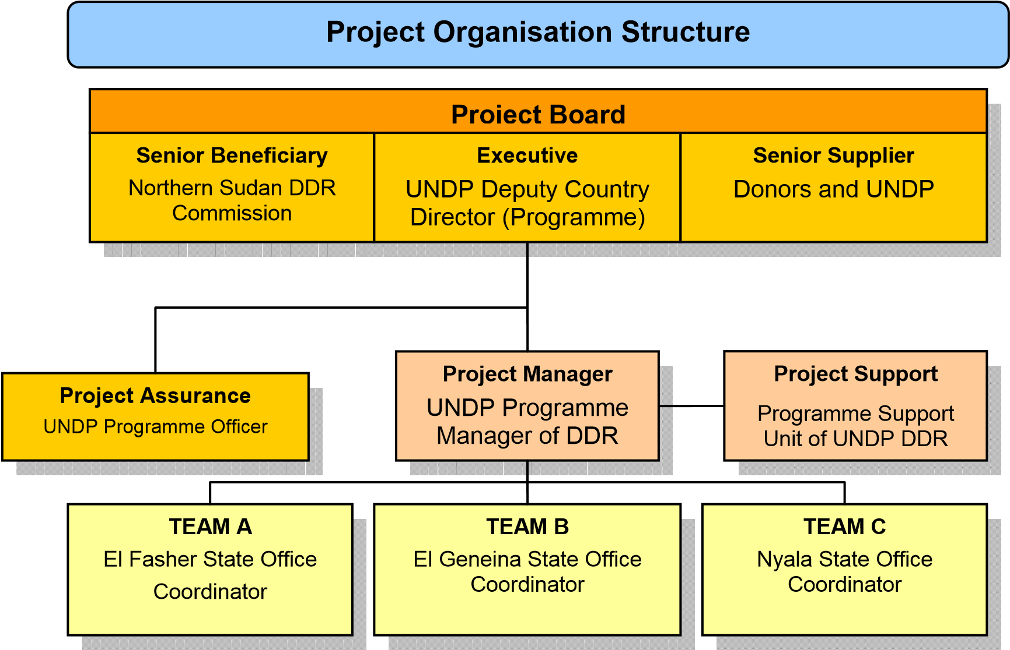

Structure of the Project Unit of the Preparatory Support Project for DDR in Darfur

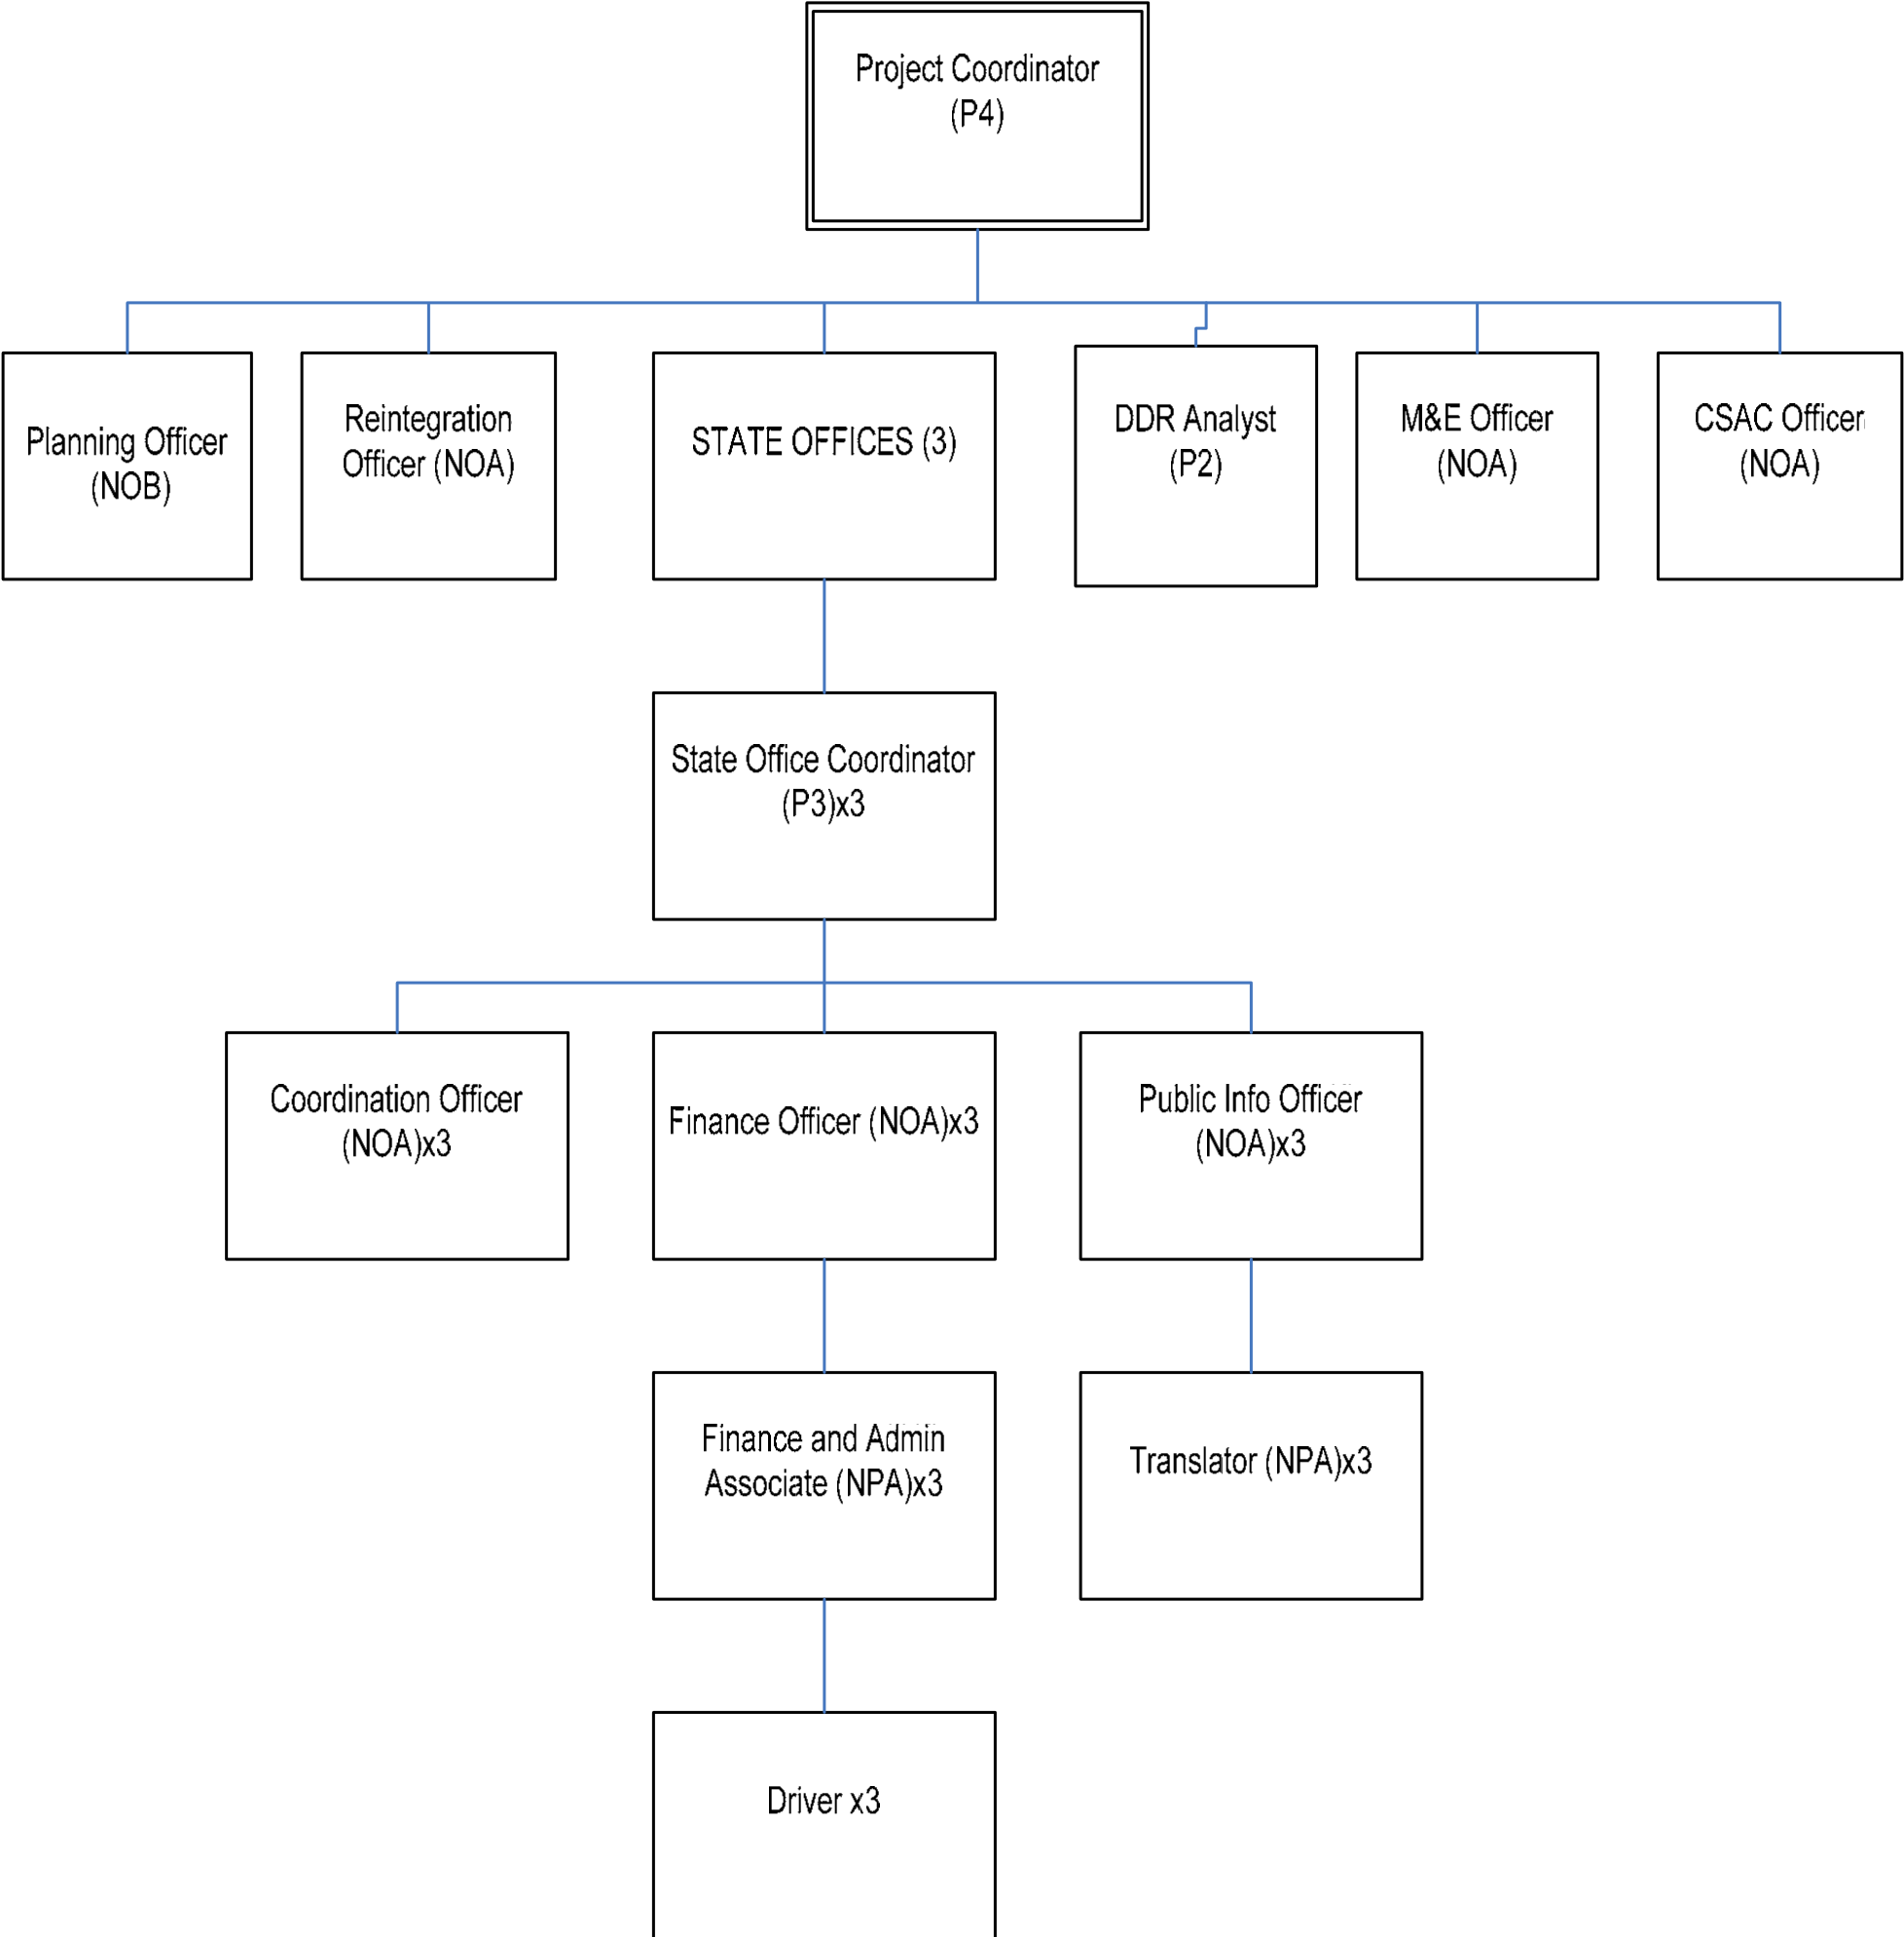

VI. MONITORING AND EVALUATION FRAMEWORK
Day-to-day monitoring of the project will be the responsibility of each Sub-regional Office Coordinator under the overall supervision of the UNDP Programme Manager. UNDP DDR Section will ensure that key stakeholders are kept appraised of progress in the following steps. The project will also be subject to a midterm review and end-of-project evaluation to take stock of overall progress, identify lessons learned and make recommendations to the Project Board for the main phase of Darfur DDR. A joint M&E team consisting of NSDDRC and UNDP will conduct the review and evaluation to jointly report to the Project Board.

The project will be monitored through the following within the annual circle:

- On a quarterly basis, a quality assessment shall record progress towards the completion of key results, based on quality criteria and methods captured in the Quality Management table below.
- An Issue Log shall be activated in Atlas and updated quarterly by the Project Manager to facilitate tracking and resolution of potential problems or requests for change.
- Based on the initial risk analysis submitted, a risk log shall be activated in Atlas and quarterly updated by reviewing the external environment that may affect the project implementation.
- Based on the above information recorded in Atlas, a Quarterly Progress Reports (QPR) shall be submitted by the Project Manager to the Project Board through Project Assurance, using the standard report format available in the Executive Snapshot.
- A project Lesson-learned log shall be activated and quarterly updated to ensure on-going learning and adaptation within the organisation, and to facilitate the preparation of the Lessons-learned Report at the end of the project
- A Monitoring Schedule Plan shall be activated in Atlas and updated quarterly to track key management actions/events
- A Final Review Report shall be prepared by the Project Manager and shared with the Project Board. As minimum requirement, the Final Review Report shall consist of the Atlas standard format for the QPR covering the whole year with updated information for each above element of the QPR as well as a summary of results achieved against pre-defined annual targets at the output level.
Annually, the project will be monitored through the following:
- Annual Review Report. An Annual Review Report shall be prepared by the Project Manager and shared with the Project Board and the Outcome Board. As minimum requirement, the Annual Review Report shall consist of the Atlas standard format for the QPR covering the whole year with updated information for each above element of the QPR as well as a summary of results achieved against pre-defined annual targets at the output level.
- Annual Project Review. Based on the above report, an annual project review shall be conducted during the fourth quarter of the year or soon after, to assess the performance of the project and appraise the Annual Work Plan (AWP) for the following year. In the last year, this review will be a final assessment. This review is driven by the Project Board and may involve other stakeholders as required. It shall focus on the extent to which progress is being made towards outputs, and that these remain aligned to appropriate outcomes.

Quality Management for Project Activity Results
Replicate the table for each activity result of the AWP to provide information on monitoring actions based on quality criteria. To be completed during the process “Defining a Project” if the information is available. This table shall be further refined during the process “Initiating a Project”.

OUTPUT 1: Capacity Development of National Stakeholders aimed at establishment of institutional structures and core functions for Darfur DDR
Activity Result 1  (Atlas Activity ID) | Offices deployed within projected timeline, operational and implementing activities |  | Start Date: 1 Sep 2009  End Date: 28 Feb 2011
Purpose | Develop the NSDDRC’s capacity to set up operational structures, including Darfurian staff, to strengthen the DDR institutional framework.
Description | Action 1.1.: Three State Offices identified and established in El Fasher, El Geneina and Nyala  Action 1.2.: Three state offices are equipped with required vehicles, furniture and office equipment  Action 1.3.: Legislative and institutional frameworks for sustainable functioning of the three institutions developed and formalised  Action 1.4.: ToRs required for the DDR project staff agreed upon, developed and institutionalized  Action 1.5.: Recruitment and training of required staff on administrative functions deployment to state and branch offices
Quality Criteria |  | Quality Method  Means of verification. What method will be used to determine if quality criteria has been met? | Date of Assessment  When will the assessment of quality be performed?
(1) Management system of Darfur DDR established and State Offices set up with required personnel and office equipment and infrastructure at place |  | State offices are operating to support Darfur DDR.  Based on peace negotiation process led by UNAMID, DDR eligibility criteria developed and formalized | Quarterly
(2) National actors are willing to provide services for full-fledged Darfur DDR project |  | Based on peace negotiation process, MoU or letter of commitment for implementation of the full-fledged Darfur DDR project is signed between NSDDRC and UNDP | 1 Mar 2010  28 Feb 2011

OUTPUT 1: Capacity Development of National Stakeholders aimed at establishment of institutional structures and core functions for Darfur DDR
Activity Result 2  (Atlas Activity ID) | SOPs and operational guidelines developed |  | Start Date: 1 Sep 2009  End Date: 28 Feb 2011
Purpose | Develop Darfur-specific key DDR programme tools such as SOPs and operational guidelines, as well as technical Capacity to operate them
Description | Action 1.1.: Joint (NSDDRC state offices and the UN) preparation and development of operational guidelines and SOPs for Darfur DDR implementation  Action 1.2.: Formalization and/or institutionalization of SOPs and operational guidelines
Quality Criteria |  | Quality Method  Means of verification. What method will be used to determine if quality criteria has been met? | Date of Assessment  When will the assessment of quality be performed?
(1) Jointly developed Darfur DDR |  | Experts/peer review | 1 Jun 2010
SOPs and operational guidelines are in line with IDDRS and Darfur Peace  Agreement documents | Provision or Decree on institutionalization of the SOPs and operational guidelines for Darfur regions
(2) National counterparts from State  Offices are trained and capable to use  SOPs and operational guidelines | Report on the end-user survey (satisfaction and needs assessment of key professional staff) | 1 Dec 2010

OUTPUT 1: Capacity Development of National Stakeholders aimed at establishment of institutional structures and core functions for Darfur DDR
Activity Result 3  (Atlas Activity ID) | Activity Result (3) Commission staff trained and applying training to the implementation of activities within Darfur DDR. |  | Start Date: 1 Sep 2009  End Date: 1 Dec 2010
Purpose | National counterparts responsible for Darfur DDR project implementation are provided with required skills and technical expertise to run full-fledged DDR programme
Description | Action 3.1.: Develop capacity development strategy and training programme for required staff of the state offices  Action 3.2.: Conduct a series of trainings and workshops for required staff in various programme areas including DDR, special needs groups, CSAC, gender etc.
Quality Criteria |  | Quality Method  Means of verification. What method will be used to determine if quality criteria has been met? | Date of Assessment  When will the assessment of quality be performed?
(1) DDR concept and activities wellinformed at the State government level and their proactive support expected. |  | Based on peace negotiation process,  National Strategic Plan for Darfur DDR reflects commitment to implementation of the full-fledged  Darfur DDR | 1 Mar 2010
(2) Key (professional) staff are satisfied with the technical support received. |  | Report on the end-user survey (satisfaction and needs assessment of key professional staff) | 1 Dec 2010

OUTPUT 2: Undertake a DDR public information and sensitization campaign for DDR in Darfur
Activity Result 1  (Atlas Activity ID) | Activity Result (1) State governments and leaders of communities prepared the implementation of comprehensive DDR and realized that a weapon-free society is more conducive to stability and development than one in which access to weapons is prevalent. DDR receives political support from regional figures. |  | Start Date: 1 Dec 2009  End Date: 28 Feb 2011
Purpose | To ensure public and state government support to the project
Description | Action 1.1.: Conduct a series of workshops on DDR and CSAC Sensitisation Campaign at the State government level  Action 1.2.: Conduct a series of workshops on DDR and CSAC Sensitisation Campaign at the community level Action
Quality Criteria |  | Quality Method  Means of verification. What method will be used to determine if quality criteria has been met? | Date of Assessment  When will the assessment of quality be performed?
DDR concept and activities wellinformed at the State government level and their proactive support to the |  | Training reports (results of ex-ante and ex-post assessment of trainees) | 28 Feb 2010  28 Feb 2011
project provided.
DDR concept and activities wellinformed in the population and their proactive support to the project provided. | Training reports (results of ex-ante and ex-post assessment of trainees) | 28 Feb 2010  28 Feb 2011

OUTPUT 2: Undertake a DDR public information and sensitization campaign for DDR in Darfur
Activity Result 2  (Atlas Activity ID) | Activity Result (2) Population including armed groups well-informed about DDR. Armed groups encouraged to enter DDR process. |  | Start Date: 1 Dec 2009  End Date: 30 Nov 2010
Purpose | To ensure awareness and benefits of the programme by the potential candidates for DDR
Description | Action 2.1.: Initiate and conduct a series of public information and sensitization events based on outreach strategy developed, including design and broadcast a series of radio programmes on DDR and CSAC Sensitisation in state capitals and communities.  Action 2.2. Initiate meetings with commanders and community leaders in high priority communities to raise awareness on DDR processes and benefits  Action 2.3.: Lobbying and facilitating a dialogue between the key players of the process
Quality Criteria |  | Quality Method  Means of verification. What method will be used to determine if quality criteria has been met? | Date of Assessment  When will the assessment of quality be performed?
(1) Number and coverage of radio programmes and other cultural events to raise awareness and sensitization on DDR process |  | Reports on PIS events conducted by  Public Information Officer  Mass media reports | 1 Jun 2010  1 Dec 2010
(2) Feedback collected from commanders and community leaders on raising awareness on DDR processes and benefits. |  | Minutes/reports on meetings  conducted | Biannually

OUTPUT 3: Action Plan for the full-fledged Darfur DDR programme agreed upon and designed in a participatory manner with all key stakeholders involved
Activity Result 1  (Atlas Activity ID) | Activity Result (1) A comprehensive participatory consultative process to design Darfur DDR project concept, strategy and workplan facilitated. |  | Start Date: 1 Jul 2009  End Date: 31 Dec. 2010
Purpose | DDR concept and activities are informed at the State governments level as well as population. DPA, particularly its security components, is also notified.
Description | Action 1.1.: Conduct consultations and discussions with institutions and key partners on policy development, drafting of policy and joint meetings to review and agree on policies and implementation strategies  Action 1.2.: Develop CSAC strategy and project document under the Darfur DDR framework with linkage to National CSAC Strategy of NSDDRC  Action 1.3.: Key programme tools, including baseline surveys, reintegration mapping exercises and MIS, are jointly developed and implemented by national counterparts and UNDP  Action 1.4.: Draft a full-fledged project document for Darfur DDR and submit for endorsement to the NSDDRC
Quality Criteria |  | Quality Method  Means of verification. What method will be used to determine if quality criteria has | Date of Assessment  When will the assessment of quality be performed?

 | been met?
Feedback collected during the consultation and discussion process with key partners on DDR and CSAC. | Protocol/minutes of consultative meetings on full-fledged DDR  programme design | Quarterly
Key programme tools jointly developed by NSDDRC and UNDP (baseline surveys, reintegration mapping exercise and MIS) serve as a basis for planning full-fledged DDR project | Project document developed details all required technical aspects for implementing a full-fledged DDR project | 28 Feb 2010  28 Feb 2011
The main phase DDR project concept, document and workplan including financial and managerial arrangements formalized. | Project document signed | 28 Feb 2010  28 Feb 2011

VI. LEGAL CONTEXT
This document together with the CPAP signed by the Government and UNDP which is incorporated by reference constitute together a Project Document as referred to in the SBAA [or other appropriate governing agreement] and all CPAP provisions apply to this document.
Consistent with the Article III of the Standard Basic Assistance Agreement, the responsibility for the safety and security of the implementing partner and its personnel and property, and of UNDP’s property in the implementing partner’s custody, rests with the implementing partner.
The implementing partner shall:
- put in place an appropriate security plan and maintain the security plan, taking into account the security situation in the country where the project is being carried;
- assume all risks and liabilities related to the implementing partner’s security, and the full implementation of the security plan.
UNDP reserves the right to verify whether such a plan is in place, and to suggest modifications to the plan when necessary. Failure to maintain and implement an appropriate security plan as required hereunder shall be deemed a breach of this agreement.
The implementing partner agrees to undertake all reasonable efforts to ensure that none of the UNDP funds received pursuant to the Project Document are used to provide support to individuals or entities associated with terrorism and that the recipients of any amounts provided by UNDP hereunder do not appear on the list maintained by the Security Council Committee established pursuant to resolution 1267 (1999). The list can be accessed via http://www.un.org/Docs/sc/committees/1267/1267ListEng.htm. This provision must be included in all sub-contracts or sub-agreements entered into under this Project Document”.

VIII. ANNEX

Risk Analysis
This project is contingent on continued political commitment to resolve conflicts in Darfur and protect civilians from rebel violence. Success of the project extremely depends upon the sustained political will of all parties concerned and their commitments to the Darfur Peace Agreement.
The project will only succeed within an inter-agency framework and a multi-sectoral approach. Finally, this project is dependent on adequate funds to enable its full implementation.

RISK LOG

Project Title: The Preparatory Support Project for DDR in Darfur | Award ID: | Date:
# | Description | Date  Identified | Type | Impact &  Probability | Countermeasures / Mngt response | Owner | Submitted, updated by | Last  Update | Status
1 | Continued political  commitment to the DPA, resolution of conflicts in Darfur | 26 May  2008 | Political | Without political commitment of GoNU, GoSS, all armed groups involved and any other political stakeholders in the region, the formal DDR will never succeed and have no impact on security improvement.  Probability = 3-4  Impact = 5  1 (low) to 5 (high) | - Cease hostilities through a constructive dialogue and negotiation  - Urge compliance of parties to disarmament and forces withdrawal provisions made in the DPA  - Will facilitate the agreement on eligibility criteria for the individuals to enter the programme. | UNAMID | Tomokazu Serizawa,  UNDP | 2 August  2009 | Increasing
2 | Inter-agency framework and a  multi-sectoral approach | 26 May  2008 | Organisational | Clear demarcation of the functional role in Darfur DDR between UNDP and UNAMID  will be the key to success from the viewpoint of interagency framework.  P = 1-2  I = 4 | - Hold regular interagency meeting  - Agree on ToRs | UNDP | Tomokazu Serizawa,  UNDP | 2 August  2009 | No change
3 | Adequate funds to enable its full | 26 May  2008 | Financial | Although the necessity of DDR in Darfur is fairly acknowledged in | • Hold meetings with  NSDDRC on financial | UNDP | Tomokazu Serizawa, | 2 August  2009 | No change

 | implementation |  |  |  | the GoNU and the  international community, whether adequate funds are provided will be subject to mainly Sudan/Darfur political situation.  P = 2-3  I = 5 | requirement  - Hold ad-hoc meeting with prospective donors and reach agreement on contributions  - In addition to the funding being offered by BCPR, the UNDP Sudan Country  Office is allocating $300,000 for the start up costs of the project. The GONU will contribute an additional $600,000. To meet the funding requirements, UNDP DDR team is routinely engaging with traditional and nontraditional donors, several of whom have expressed interest in the project. A proposal has also been submitted to the Peacebuilding Fund. Raising additional funds will be facilitated by getting the project off the ground as soon as possible |  | UNDP
4 | Support of  national, local government and communities to assist in the DDR including return  of ex-combatants  to difficult economic circumstances | 26  2008 | May | Strategic | The situation requires massive public  relations efforts about how DDR can be  effective to ease the tension of conflict and difficult economic conditions.  P = 3  I = 4 | - Establish PI strategy  - Hold workshops at the state and local levels  - Use local media like radio or newspaper to disseminate messages | NSDDRC | Tomokazu Serizawa,  UNDP | 2 August  2009 | No change

5 | Armed conflict, assault, and banditry in the region and protection of civilians from violence | 26  2008 | May | Security | Although the security situation in Darfur is relatively calm in most of the region, sporadic but heavy fighting, rampant banditry can severely hamper the DDR operation. Also the increase of security phase could limit the activity and presence of UNDP staff.  P = 3  I = 4 | - Cease hostilities through a constructive dialogue and negotiation  - Enhance patrolling activities by UNAMID or local police  - UNDP senior management may need to reconsider the staff ceiling in the region. | GoNU, UNAMID | Tomokazu Serizawa,  UNDP | 2 August  2009 | No change

Budget of establishing infrastructure and enabling environment for Darfur DDR project
Description | No. | Monthly Rate | No. of  Months | Total
ACTIVITY 1 Establishment of Institutional Structures
Office Equipment (copier, fax, scanner, UPS) | 3 | 10,000 |  | 30,000
Furniture | 3 | 10,000 |  | 30,000
Vehicle | 6 | 40,000 |  | 240,000
Generator | 3 | 10,000 |  | 30,000
IT Equipment (computer, printer, accessories, software, internet) | 3 | 20,000 |  | 60,000
Communication Equipment (mobile, Thuraya, charges, radio, codan) | 3 | 1,000 | 18 | 54,000
Operational Cost (fuel & services for vehicle and generator) | 3 | 2,000 | 18 | 108,000
Office Supply (stationery) | 3 | 200 | 18 | 10,800
ACTIVITY 1 Total |  |  |  | 562,800
ACTIVITY 2 Capacity Building of National Stakeholders
M&E Officer (NOA) | 1 | 2,306 | 12 | 27,672
Reintegration Officer (NOA) | 1 | 2,306 | 12 | 27,672
Community Security Officer (NOA) | 1 | 2,306 | 12 | 27,672
Coordination Officer (NOA) | 3 | 2,306 | 12 | 83,016
State Office Coordinator (P3) | 1 | 16,000 | 18 | 288,000
State Office Coordinator (P3) | 2 | 16,000 | 12 | 384,000
DDR Analyst (P2) | 1 | 12,000 | 18 | 216,000
Training (trainee, accommodation, rent, stationery, material) | 3 | 1,500 | 12 | 54,000
SOP and Operational Manual (100 volumes for each, paper material) | 3 | 1,000 |  | 3,000
Travel and DSA for Participants | 3 | 2,000 | 12 | 72,000
ACTIVITY 2 TOTAL |  |  |  | 1,183,032
ACTIVITY 3 Sensitisation
Outreach Strategy Development | 1 | 15,000 |  | 15,000
Meeting in El Fasher (Regional Level) x 2 | 6 | 5,000 |  | 30,000
State Meeting with Leaders x 12 | 12 | 2,000 |  | 24,000
Meeting at Community Level X20 | 20 | 1,000 |  | 20,000
Radio Programme |  |  |  | 25,000
Travel and DSA for Participants | 3 | 5,000 | 12 | 180,000
Public Information Officer (NOA) | 1 | 2,306 | 18 | 41,508
Translator (NPA) | 1 | 1,600 | 18 | 28,800
Translator (NPA) | 2 | 1,600 | 12 | 38,400
Public Information Officer (NOA) | 2 | 2,306 | 12 | 55,344
Leaflet/Material/other |  |  |  | 51,000
ACTIVITY 3 Total |  |  |  | 509,052
ACTIVITY 4 Programming
Finance Officer (NOA) | 1 | 2,306 | 18 | 41,508
Finance Officer (NOA) | 2 | 2,306 | 12 | 55,344
Planning Officer (NOB) | 1 | 3,534 | 18 | 63,612
Finance and Administration Associate Officer (NPA) | 3 | 1,600 | 12 | 57,600
Audit |  |  |  | 15,000
Evaluation |  |  |  | 15,000
Travel and DSA for Staff | 3 | 1,800 | 18 | 97,200
Project Coordinator (P4) | 1 | 19,764 | 18 | 355,752
Driver | 1 | 800 | 18 | 14,400
Driver | 2 | 800 | 12 | 19,200
Conduct baseline survey/subcontracting | 3 | 60,000 |  | 180,000
ACTIVITY 4 Total |  |  |  | 914,616
Sub Total Programme Cost |  |  |  | 3,169,500
UNDP GMS (7%) |  |  |  | 165,865
UNDP GMS (3%)* |  |  |  | 6,000
Contingency expenditure (3%) |  |  |  | 95,085
Grand Total |  |  |  | 3,436,450
* from the government contribution (200,000 USD)

29

Tanner, Victor and Jerome Tubiana. 2007. “Divided They Fall: The Fragmentation of Darfur’s Rebel Groups” Baseline Assessment Project of the Small Arms Survey No.6, Small Arms Survey, Switzerland. July 2007. p14.
The UN defines a SALW as “any man-portable lethal weapon that expels or launches, is designed to expel or launch, or may be readily converted to expel or launch a shot, bullet or projectile by the action of an explosive.” Commercially manufactured and crafted SALW, ammunition and explosives are included in this definition.

